**CS 2302 Data Structures**

**Fall 2019**

**Lab Report #5**

Due: November 1, 2019

Professor: Olac Fuentes

TA: Anindita Nath

**Introduction**

Lab 5: Hash Tables focuses on developing a program that will store word embeddings in a hash table with chaining or linear probing based on the user’s preference. The user was also able to select the hashing function for the hash table. After storing the data in the chosen data structure, the similarities between the pairs of words are computed. The word pairs are located in a file which contain two words per line, separated by commas. In order to identify the similarities between the words, their vectors must be compared. Thus, the program will search the hash table to find the two words and retrieve the emb attribute from the WordEmbedding object. In order to compare the words, the cosine distance is used. In order to find the cosine distance, the dot product of the first embedding and second embedding is divided by the magnitudes of the first embedding and second embedding. The efficiency of the hash tables and hash functions are then compared by analyzing the runtimes for construction and computation of similarities. Since a major theme of this lab was to compare the different data structures, the runtimes for the B-Trees and BSTs obtained from Lab 4 are compared.

**Proposed Solution Design and Implementation**

**Overall Design**

This lab consists of four files: HashTableLPClass.py, HashTableChainClass.py, WordEmbedding.py, and NicholeMaldonado_Lab5.py. HashTableLPClass.py, HashTableChainClass.py, and WordEmbedding.py contain the designated class as well as any specific methods that are related to the class. For example, the word embedding insertion method and find methods are included. The main part of the program lies in the NicholeMaldonado_Lab5.py. This portion of program signals the actual creation of the Hash TAble and interprets the users input. It is essentially the backbone of the lab. I decided to use four files to keep all of my classes separated and organized. Just Lab 4 had different files for each class, I wanted to keep the designs as consistent as possible. This was crucial to evaluating the overall performances between the different data structures.

**Part 1**

Main Design

Based on the described output, the main functionality of the program builds a Hash Table with Linear Probing or Chaining. The hash function used by the table is designated by the user. The user also selects whether they want to insert a pair of words or input a large list of words through a file. The chosen Hash Table with the hash function will then be filled with user embedding and each pair of words are retrieved from the table. The similarities of each word pair are calculated and then displayed. During the program, the runtime for the table’s construction and search are also exhibited. Since two files are needed, I decided to first have the program prompt the user to enter the file path for each file or pair of words. After receiving the file paths, each path is first checked to ensure that it is a .txt file. I thus, used the same method from Lab 1 in order to ensure that the program would not attempt to open some other miscellaneous file, like a .jpg for example. The user is then given the option to use a Hash Table with Chaining or Linear Probing to store the word embeddings and retrieve the designated word embeddings. I therefore created two separate functions, chaining_analysis and linear_probing_analysis, which would both perform the same tasks but for the different tables. I enclosed each method call around a try block, in the event that an error occurred while trying to access any of the two files. For the chaining_analysis and linear_probing_analysis, the file paths, the hash designated hash function number, and table size were accepted as parameters. For the table size, the user could select to either have a table two times or 1.3 times the size of the glove.6B.50d.txt file. By having this capability, the effects of a table’s load factor would later be analyzed. As for the hash function number, they are based on the following: (1) Length of the word (2) Ascii Value of the first letter (3) Ascii value of the first and last letter (4) Ascii sum (5) A recusive Horner’s method (6) Custom. Both functions would then call their corresponding hash table “setup” function where the tables would be created and populated. After the hash table was created, it would be returned to the method. If the user had decided to compare the word pairs from a file, then the find_similarities_file function would be called. This function would find the similarities and return the runtime. If the user had entered their own pair of words, then the find_similarities function would be called. This function would also compute the similarity between the words and return the runtime. The runtime would then be printed, and the program would terminate. Unlike the BST and B-Tree, the Hash Tables for linear probing and chaining have the same function names and requirements for finding the word_embedding so a single function was able to handle either of these instances. For my method I chose a coefficient of 133 and obtain the value of 133 to the ith power times the ascii value of the current character. This part is similar to Horner’s method. Then, since I realized that the murmur method was using bit manipulation, I decided to XOR the term described above with 37 to the ith power. The reason why I choose 37th to the ith power was partly due to the multiplicative method which uses a constant prime value. I chose to make it the ith power since the length of the words could vary and a letter at a specific index could easily vary amongst the other words. Initially, I had just decided to perform the summation of the ascii values times the position, however the running times were too long. However, from this trial, I learned that the position of the character can have a large role in making a hashing function map keys to different indices. Lastly, I also tried switching the bits for the first ascii value of the word by using the “<<” operator. However, this resulted in a longer running time, so this idea was abandoned.

**Part 2**

Custom Hashing Function

For my hashing function, I first researched online the way to best obtain a hashing function. Many authors stressed the importance of creating a unique hashing function that would map a limited number of keys to an index. From my research, I learned about three different hashing functions: Horner’s method, the Multiplication method, and Murmurs hashing function. Initially, I was going to use Horner’s method which is essentially a polynomial where the coefficient is usually a prime number in the form of a + ax + ax^2 + …. In this example, “x” would be the ascii value of the word. After researching more about this function, I realized that the recursive function was essentially applying Horner’s method. I then looked at the multiplication method which is primarily used for integers. However, this method would be crucial for my own method creation because I realized that multiplying by a coefficient was used in this method as well as Horner’s method. From the murmur method, I saw different values being appended and XOR operations being applied. I thus decided to combine Horner’s method with the murmur method.

Hash Table with Chaining Construction

The main construction method for the Hash Table with chaining is file_to_chaining. This function takes the file path of the glove.6B.50d.txt file, the hash function number, and the table size as a parameter. Unlike the BST and B-Tree, the Hash Table requires a predetermined size. In order to approximate the best size, the file is completely read first the number of lines. Once the total number of lines are calculated, the Hash Table is created with the size times the table size parameter. Then, the file is read from the beginning again. Although one may see this as wasteful, it is the best solution. Initially, I was going to hardcode a table size, but I realized that the size of the glove.6B.50d.txt file would change to accommodate the long running times for the Hash Table with linear probing. Another solution that I thought of require resizing the hash table. However, this would result in O(n) runtime, which is equivalent to reading the file once and then rereading the file to populate the table. Thus, I decided to choose my initial idea. As each line is read, it is processed and turned into a WordEmbedding object. The line is first striped of any newlines. A check also ensures that the word only contains letters. After the line is checked, it is split by spaces into a list. The word of the WordEmbedding object is then assigned to the value at index one and the emb attribute is assigned to the rest of the list. With the WordEmbedding object created, it is then inserted into the Hash Table.

The insert function for the Hash Table with chaining is fairly straightforward. It takes the word embedding and hashing function number as the parameters. The bucket where the element should reside is found by calling the hashing function “h”. This function takes the hashing function number and calls the correct hashing function. The bucket along with the word embedding is then passed to the method binary insertion. This method is the same method used in Lab 5 for the B-Tree. Just as the B-Tree had a list of data, each bucket has a list of data. By calling this method, the word embedding is placed in its correct ordered position if it does not already exist in the list. Using the binary insertion was a very important design decision that I made. Initially, I just appended the word embedding at the end of the list. However, when a search for that word embedding occurred, only a linear search could be applied. This resulted in extremely long running times. Thus, I realized that if I order the data as I am inserting it, the find operation would be easier resulting in faster running times.

After all the lines were read and all the word embedding objects were added to the hash table, I returned the hash table and the performance time. The performance time was calculated by subtracting the time the first line of the file was read to the end of the iterations.

As for the efficiency of the function, m word_embeddings will be added to the hash table. Thus, the insertion method will be called m times. The insertion method find the bucket where the element should be located in constant time. Then, a binary insertion is applied that will repeatedly divide the list in half until the word embedding correct insertion place is found. This single process results in O(logn) time where n is the number of elements in the bucket. Although hash tables are supposed to have insertions and finds in constant time, it is important to note that the O(logn) time is preferable. If word_embeddings were just appended, then finding the element would result in O(n). As the tests will later demonstrate, these chains can become extremely long, sometimes reaching 700 elements. By ordering these elements as they are inserted, one can avoid having to look through 700 elements just to find that the element is not in the bucket.

Hash Table with Linear Probing Construction

The main construction method for the B-Tree is file_to_linear_probing. This method takes the file path of the glove.6B.50d.txt file, the hash function number, and the table size as the parameter. Similar to the Hash Table with Chaining, the file is first read to approximate the number of elements that will be stored in the Hash Table. The number of lines is then multiplied by the table size factor, designated by the user, and applied as the size attribute of the table. Each line of the file is read one at a time. Similar to the all previous implementations, as each line is read, it is processed and turned into a WordEmbedding object. The line is striped of any newlines and is checked to ensure that the word only contains letters. The word_embedding object and hash function number as passed as parameters.

The insertion method for the Hash Table with Linear Probing is the same code provided in class, however it has adjustments. Since the values that we have worked with in class are integers, the next bucket to be analyzed can easily be computed by calling the hash function and passing in the value as well as the current index i. However, since word embeddings are being inserted, the word and i cannot simply be passed to the hash function to reach the next bucket. Thus, initially, I assign the position to bucket where the value is mapped and then for ever value of i after 0, the position is updated to the next bucket. Since duplicates are not allowed, I first check if the current element’s word is the word to be inserted. If it is, then -1 is returned. It is crucial to note that the item attribute contains a list of -1’s and word embedding objects. Thus, if an exception is thrown while trying to access the elements word attribute, the exception is caught. This exception clearly denotes that the element is an integer and therefore the word embedding object is inserted and the position is returned.

After all the WordEmbedding objects are inserted, the hash table and the performance time are returned. The performance time was also calculated by subtracting the time of the first line read from the end of all the iterations.

As for the efficiency of the function, m word_embeddings will be added to the hash table. Thus, the insertion method will be called m times. In the best case scenario, the correct bucket will be found and the word embedding object will be inserted in constant time. However, as future tests will demonstrate, based on the hash function, the scenarios can change. If more elements are hashed to an index, more collisions will occur resulting in longer insertion times, since the list has to be iterated through until an integer is reached. In the worst case, one could assume that a numerous amount of collisions have occurred resulting in the entire list to be iterated through.

**Part 3**

Compute Similarities

In order to compare the similarities, the compute_similarity function is called. This function takes the two vectors of the WordEmbedding objects as parameters. The dot product, obtained by using np.dot(), is then divided by the magnitude and returned. The magnitude is obtained by multiplying the result from the np.linalg.norm() function from the vectors.

Find Function

The main method for reading a file containing the word pairs and finding the similarity for both hash table types is the find_similarities_file function. This function takes the hash table, file path for the word pairs, and hash function number as parameters. As each file line is iterated through, the current pair of WordEmbeddings are found in the hash table. The vectors of the embeddings are then compared using the function described above. Additionally, as each line is read, the words and their similarities are added to a list. When all the pairs have been evaluated, the similarities are then displayed to the screen. I did this to make the BST, B-Tree, and Hash Function implementations as similar as possible. The performance time was calculated from the start of the file iteration to the end was then returned. One change that I did make was create an additional hash table object called index_usage_hash_table. This hash table was used to count the number of times an index was referenced. Thus, before the find operation occurred, I initialized this hash map to be the same length as the populated hash table. Then, when a specific bucket was searched for, the value at the index in the index-usage_hash_table was incremented. This hash table would then later be evaluated to find the bucket that contained the largest integer, designating the most viewed bucket. This was an important design decision that I made because I did not want to create a global hash table that would update every time an index was accessed. Thus, I made the hash table’s update as simple as possible so it would not affect the performance time for the main populated hash table. I also ran the code with and without the index_usage_hash_table and found that the object did not affect the overall performance time.

If the user had entered a pair of words rather than a file, then the find_similarities function was called. This function also found the two WordEmbeddings in the hash table, computed their similarity, displayed the results.

Hash Table with Chaining Find

In order to find the word_embedding in the hash table, the function find was used. This method took the word, hash function number, and index usage hash table as a parameter and returned the emb attribute of the WordEmbedding found. If the word was not found, then None was returned. The find function would immediately call the find_binary_search function which would perform binary search on the chain, specified by the hash function. The correct hash function was called based on the hash function number.

As for efficiency of the function, the search function for the hash table will repeatedly divide the list in half until the word embedding is found or the start index is greater than the end index. This results in a runtime complexity of O(logn) where n is the number of elements in that bucket. Since m pairs are read from the file, two calls two the search method will be made resulting in O(logn1) + O(logn2) were n1 is the number of elements in the first bucket and n2 is the number of elements in the second bucket. Thus, in total, the runtime complexity will be O(m * logn) where m is the number of pairs read from the file and n is the average number of words that a bucket can conatin.

Hash Table with Linear Probing Find

In order to find the WordEmbedding in the hash table with linear probing, the method find was used. This method took the word, hash function number, and index usage hash table as a parameter and returned the emb attribute of the WordEmbedding found. If the word was not found, then None was returned. Similar to the insertion method, the buckets were iterated by first finding the intial bucket and then updating the position to the next bucket in the list for each iteration. If the current element in the list was the word, then the embedding was returned. However, since not all the elements in the list are WordEmbedding objects, I included an except statement. If an exception was thrown while attempting to access the elements word attribute, then the element must be an integer. If the element was -1 then all searches stopped, and None was returned. Using the try and except statements were a very important design decision. At first, I was going to check the type of the element, but I realized that this is not the most suitable solution. Thus, I decided to use try and excepts which would clearly demonstrate whether the current element was an integer or WordEmbedding object.

As for efficiency, the search function for the hash table, in the best case, the word embedding will immediately be found in the corresponding bucket and returned. This would result in constant time. However, if multiple collisions occur, the worst case could result in the entire list being iterated through resulting in O(n) where n is the number of elements in the list. Just like the Hash Table with Chaining, the find method is called twice for each word. Additionally, find will be called twice for every m pairs resulting in O(m * n).

**Part 4**

Running Time Display

In order to compare the running time of the construction and similarity computation using the BST and B-Tree, I displayed each performance time after the operation occurred. These running times were usually returned to a method to be printed and displayed along with the other stats.

Hash Table with Chaining Stats

In order to display the stats of the hash table with chaining, I created a num_elements and num_empty_lists method. The num_elements would essentially count the number of word embeddings in the hash table. This would later be used to calculate the load factor by dividing the number of elements by the length of the list. The num_empty_list function was used to calculate the number of empty chains. In order to do so, a counter was initialized to 0. If an empty list was found, it was incremented. The num_empty_list function was very important to compare the distribution of the elements. Lastly, the maximum number of times that an index was called was also calculated by the most_used_index function. Since the index_usage_hash_table was the only object to use this function, this function was defined in the HashTableLPClass.py file wince the index_usage_hash_table is a hash table with linear probing. Nonetheless, it was still integral to counting the maximum number of times that an index was referenced for the hash table with chaining.

B-Tree Stats

In order to display the stats of the hash table with chaining, I created a num_elements function. The num_elements would essentially count the number of word embeddings in the hash table. This would later be used to calculate the load factor by dividing the number of elements by the length of the list. Additionally, since the hash table with linear probing does not have chains, the number of empty indices can also be calculated by subtracting the number of elements from the length of the table. Lastly, the most_used_index function was used to indetify which index had the largest value in the table. This value corresponded to the number of times that the index was referenced during the find operation.

**Experimental Results**

For the tests, the running times for the Hash Table with linear probing for the resulting hash functions exceeded the maximum amount of time: length of the string, Ascii value of the first letter, ascii value of the first and last letter and ascii sum. Due to this, a shortened glove.6B.50d.txt file was made called revised_glove.txt. It only contains 35% of the words from the original file. Since these four hash functions result in a different word file used, these tests are separated based on the glove.6B.50d.txt file used. All of the chaining hash functions and the recursive and custom linear probing hash functions all used the regular glove.6B.50d.txt file. Additionally, the number of pairs for the four linear probing hash functions highlighted above was also reduced. From the tests it was indicated that these searches with the four hash functions could not be applied on 50,000 pairs. Thus, the tests for the four hash functions only apply to small and average sized files.

**Part 1 – Hash Table Construction:**

For the hash table construction, four tests were run for the Hash Table with Linear Probing and Hash Table with Chaining. The cases tested the following load factors: 0.9, 0.75, 0.5, and 0.27. Since the load factor denotes how distributed the elements in a table are, I thought that the different load factors may affect the running times. I chose a load factor for 0.75 because it is believed by many to be the most ideal for a hash table.

Sample Output For Hash Table with Chaining:

Length of String Hashing Function

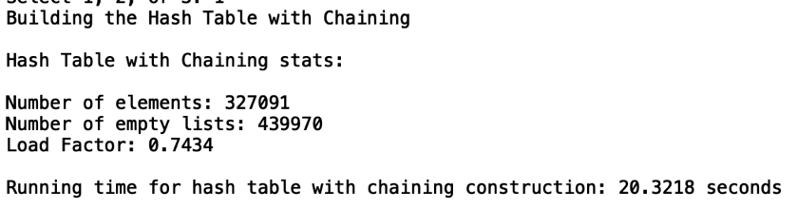

Sample Output for Hash Table with Linear Probing:

Recursive Hashing Function

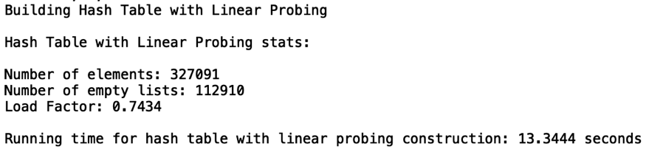

Case 1 (“0.9 Load Factor”):

pairs.txt





Case 2 (“0.75 Load Factor”):

pairs.txt





Case 3 (“0.5 Load Factor”):

pairs.txt





Case 4 (“0.27 Load Factor”):

pairs.txt









From the bar charts, it is evident that the load factors significantly changed the running times for specific hash functions. For example, the hash table with chaining’s string length profited from having a load factor of approximately 0.75 to 0.5. However, the large running time for a load factor of 0.27 is probably attributed to the large table that must be created and the hash function. Since all the words are approximately 6 to 10 letters, they will all be mapped to the index regardless of the table size. By having to construct an even larger table, more time is needed. Based on both graphs, the load factor of 0.75 seemed to have the lowest construction times. Out of the 12 different hashing functions tested, the construction of a table with a load factor of 0.75 had the lowest times for 6 of the functions. By having a moderate load factor and table size, less runtime is needed to construct a large table. As for the highest construction times the load factors of 0.9 and 0.27 had the highest construction times. For the load factor of 0.9, the large construction time resulted due to the insertion method. By having fewer empty buckets, a longer search is required to find an empty bucket. This is why the linear probing experienced higher runtimes for a load factor of 0.9. In all, the construction times for the linear probing’s four hashing functions were very similar. This may be attributed to the fact that even with a larger table, the same number of elements are still traversed. For example, the running times for the hash table with linear probing stayed the same as demonstrated in the second graph. These were the four functions that were unable to be populated from the glove.6B.50d.txt. Since the string lengths are, on average, less than 10 characters, a major cluster must have formed at the beginning of the array. Thus, increasing the size of the table would not have any noticeable changes since it is highly unlike that a word of length 300,000 exists in the file and would be mapped to that index. Lastly, these charts demonstrate an interesting trade-off for hash tables. One could ultimately create larger tables, that could result in longer construction times as seen in the first graph. In doing so, one would be using even more space that would never be filled. This results in more resources that would go unused. As for reducing a table’s size, the most stable construction times for the hashing functions was a load factor of 0.75. By decreasing the hash table’s size more, however, one could witness larger construction times as seen with the linear probing. By having elements even closer together, more space is saved, however the results of collisions are inevitable.

**Compute Similarities – Provided Output:**

For the compute similarities test, two tests were run. These tests focused finding the similarities of the pairs provided in the lab. I thought that this case was very important to identify if the compute_similarity function was producing the correct results for both the Hash Table with chaining and the hash table with linear probbing. The file tested for both cases is pairs.txt and can be found in the GitHub repository in the file TestTrialFiles.

Case 1 (“Chaining”):

Ascii Value of the First Character Hashing Function

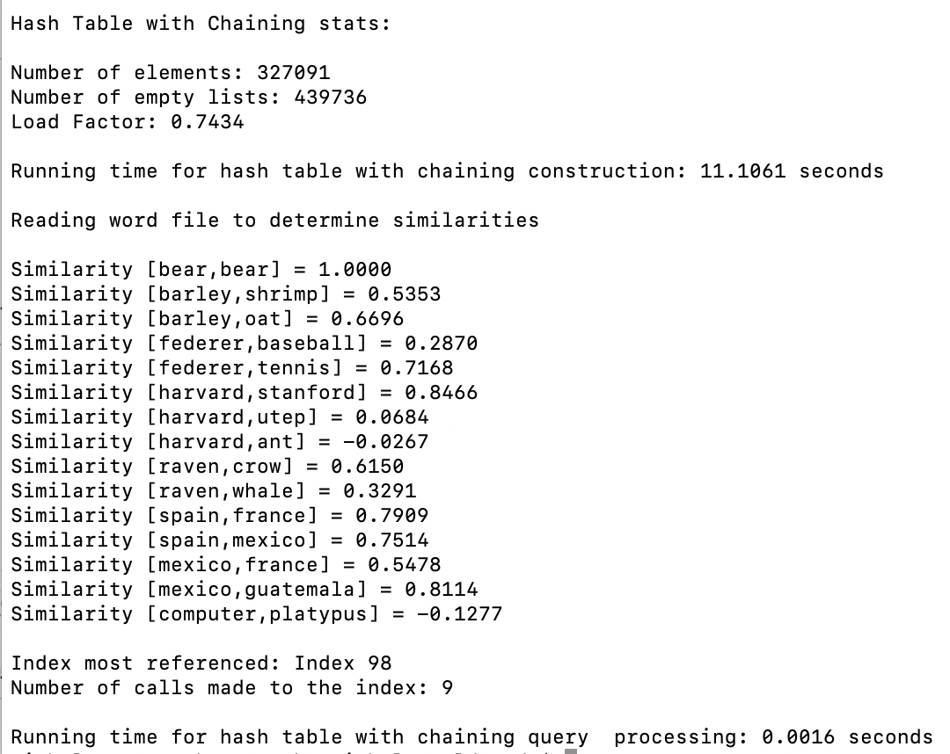

Case 2 (“Linear Probing”):

Custom Hashing Function

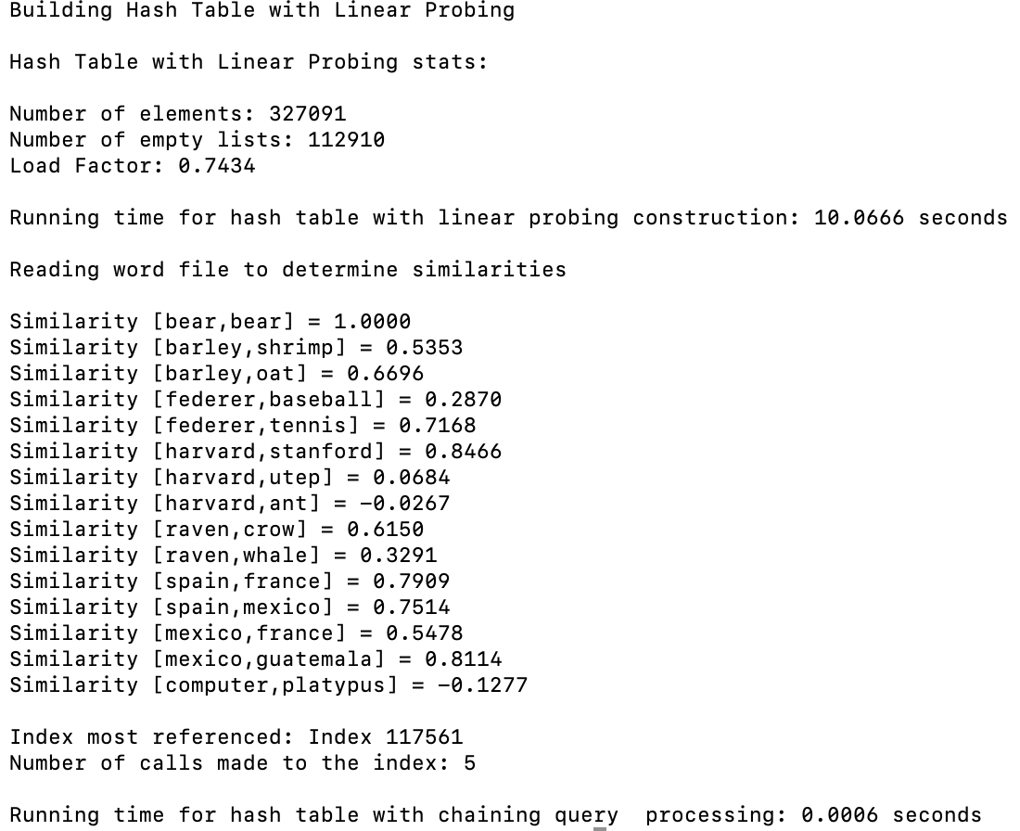

From the outputs, I was able to identify that the correct results for the similarities between the words was being computed. In doing so, I was able to focus on the running times without having to worry if the correct similarities are being computed. This test case also demonstrated that the running times for the hash tables are almost negligible since the amount of pairs are so small.

**Similarities – Small and Average Number of Pairs:**

For the Similarities test, five tests were run. These tests focused on gathering the runtime complexities for files with 100, 500, 1000, 2000, and 5000 pairs. Each test had two different trials with the .txt files corresponding to the trial number. Each .txt file contains randomly selected pairs. It is also important to note that these files were the same ones used with the trees in Lab 4. I thought that this test was very important to identify how the trees would respond to average sizes and smaller sizes of pairs. By using the same pair files, the analysis between the different data structures would be more accurate. The files tested can be found in the GitHub repository under the TestTrialFiles folder.

Sample Output for Hash Table with Chaining:

Ascii sum hashing function

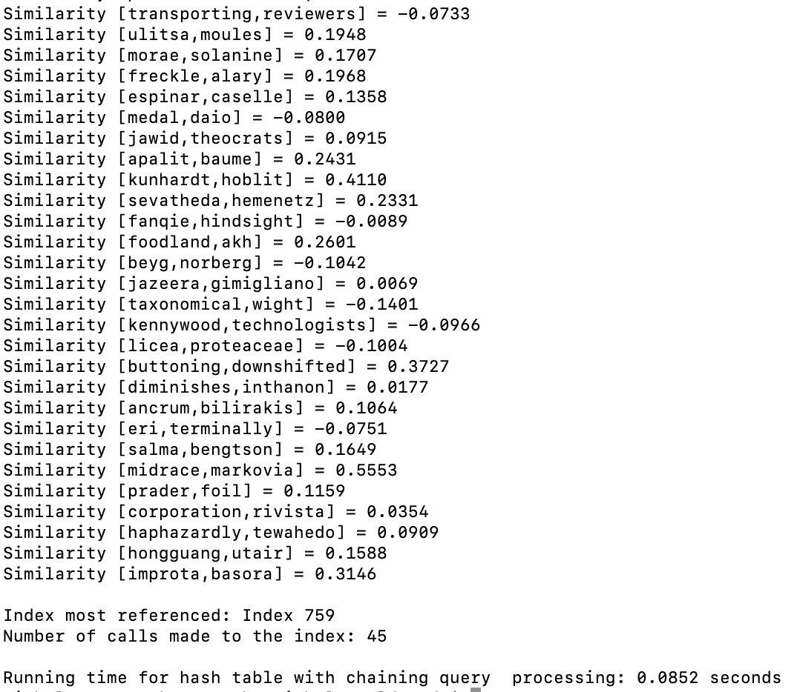

Sample Output for Hash Table with Linear Probing:

Custom hashing function

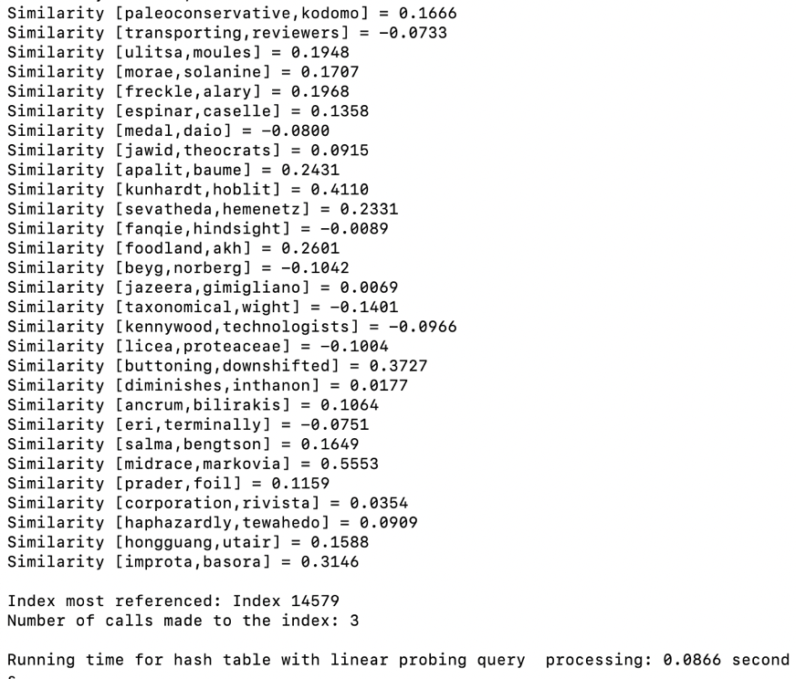

Case 1 (100):

Trial1_100.txt

Trial2_100.txt

LPTrial1_100.txt

LPTrial2_100.txt





Case 2 (500):

Trial1_500.txt

Trial2_500.txt

LPTrial1_500.txt

LPTrial2_500.txt





Case 3 (1000):

Trial1_1000.txt

Trial2_1000.txt

LPTrial1_1000.txt

LPTrial2_1000.txt





Case 4 (2000):

Trial1_2000.txt

Trial2_2000.txt

LPTrial1_2000.txt

LPTrial2_2000.txt





Case 5 (5000):

Trial1_5000.txt

Trial2_5000.txt

LPTrial1_5000.txt

LPTrial2_5000.txt









The first graph above summarizes the running times for the finding a smaller number of word pairs for all chaining hash functions and the custom and recursive hash function for the linear probing. The second graph summarizes the running times for the remaining linear probing hashing functions. Since the string length, ascii value of the first character, ascii value of the second character, and sum of ascii values ran for minutes, the tests were stopped before the tables were fully populated. Thus, a reduced glove.6B.50d.txt file was used. From these tests, it is clear that these four functions had the worst running times. Their average times were nearly identical to the other hash functions. However, the four hash functions only performed the searches on 35% of the words from the original file. The first graph demonstrates that hash table with chaining recursive function had the best running time and the linear probing custom had the worst running time. The efficiency of the recursive function further demonstrates why Horner’s method is often using for hashing functions. As for my custom hash function, viewing the graph, one may denote it as the “worst” overall. However, even though it did have the worst running times out of the 8 tested with the standard glove file, it was more consistent than a majority of the other functions. For example, even though the hash table with chaining’s ascii sum had the second lowest runtime, it only applies to the chaining hash table. For the hash table with linear probing, the program was still populating the table 3 minutes later. Thus, my custom hashing function or the recursive hash function would be better for those who wish to apply the same hashing function on both types of hash tables.

**Similarities – Medium Files:**

For the Similarities test, two tests were run. This test focused gathering the runtime complexities for files with 50,000 and 100,000. As for the hash table with linear probing, four of the functions had 10,00 as the maximum number of pairs tested. An initial test was attempted at 50,000 but the running times were too long. Thus, the final test for the linear probing’s length of word and ascii value hash functions ended at Case 1 with 10,000 pairs. Each test had two different trials with the .txt files corresponding to the trial number. Each .txt file had randomly selected pairs. I thought that this test was very important to identify how the hash tables would respond to medium sized data. I specifically chose these file sizes since 100,000 pairs is approximately a third of the number of words in the file. The files tested can be found in the GitHub repository under the TestTrialFiles folder.

Sample Output for Hash Table with Chaining:

Ascii value for first and last character

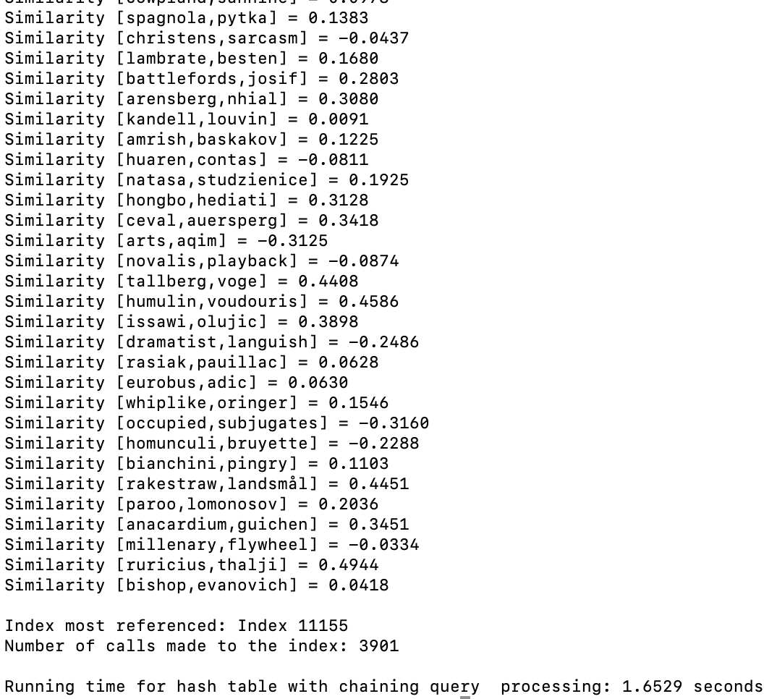

Sample Output for Hash Table with Linear Probing:

Ascii of first character hashing function

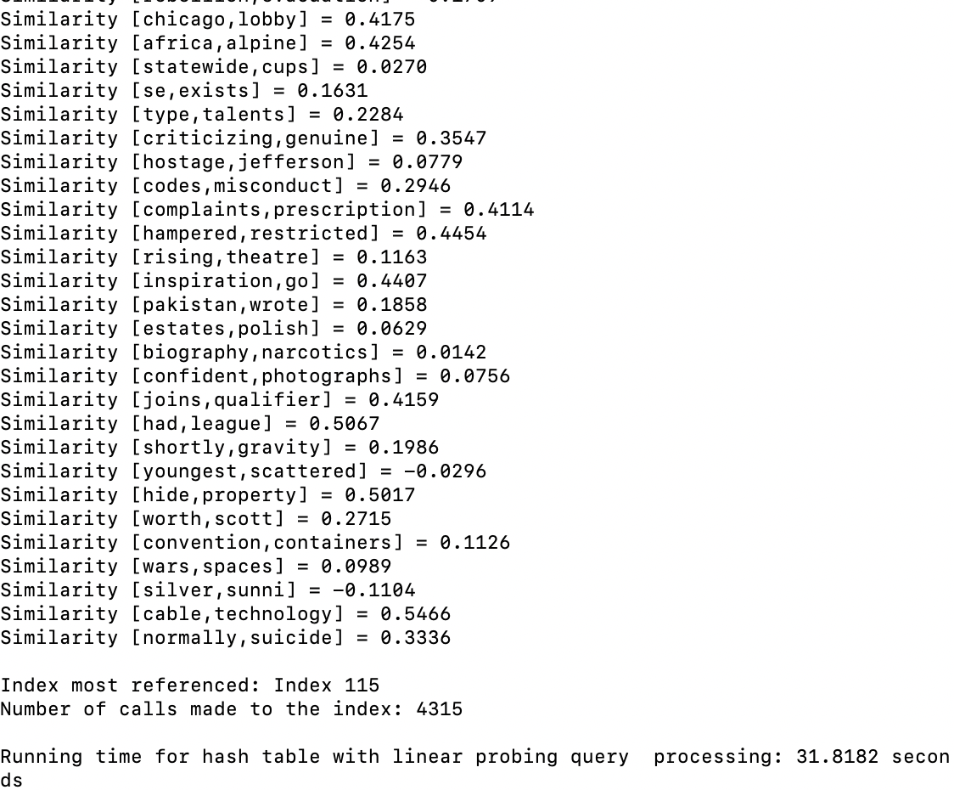

Case 1 (50,000):

Trial1_50000.txt

Trial2_50000.txt

LPTrial1_1000.txt

LPTrial2_1000.txt





Case 2 (100,000):

Trial1_100000.txt

Trial2_100000.txt







The graph above summarizing Case 1 and Case 2, demonstrates, the runtimes for the hash tables with linear probing and chaining. For the most part, the runtimes for all the data, minus the four linear probing functions depicted in the second graph, were closely related. The efficiency of the hash table with chaining’s recursive function was yet again evident. As for the hash table with linear probing’s recursive function, it experienced a longer running time for 100,000 pairs. In fact, my custom recursive function and the ascii sum function had faster performance times for the second case. This clearly highlights an interesting benefit of using hash tables with chaining. If more collisions occur, then chaining, rather than linear probing, would be the most ideal. Since the individual buckets are ordered, when binary search is performed it is constantly halving the number of elements that need to be viewed. As for the linear probing, it must continue to search one element at a time. From the second graph, the hashing function for the ascii first and last letters had a faster running time than the hashing function that only considered the ascii value of the first letter. This clearly proves that the functions are working as expected since it would be more common to have letters that start with an “a” rather than letters that start with an “a” and end with a “t”.

**Similarities – Large Files:**

For the Similarities test, three tests were run. These tests focused gathering the runtime complexities for files with 150,000, 200,000, and 300,000 pairs. Each test had two different trials with the .txt files corresponding to the trial number. Each .txt file had randomly selected pairs. I thought that this test was very important to identify how the hash tables would respond to large sizes data. I specifically chose these file sizes since 300,000 pairs is close to the 327, 091 words in the file. I wanted to test that how each algorithm would respond if a search for nearly every word was executed. Since the Linear Probing’s recursive and custom hash functions were the only functions able to be tested with such large amounts of data, these tests would be integral when comparing the running times with the trees. The files tested can be found in the GitHub repository under the TestTrialFiles folder.

Sample Output for Hash Table with Chaining:

Custom hashing function

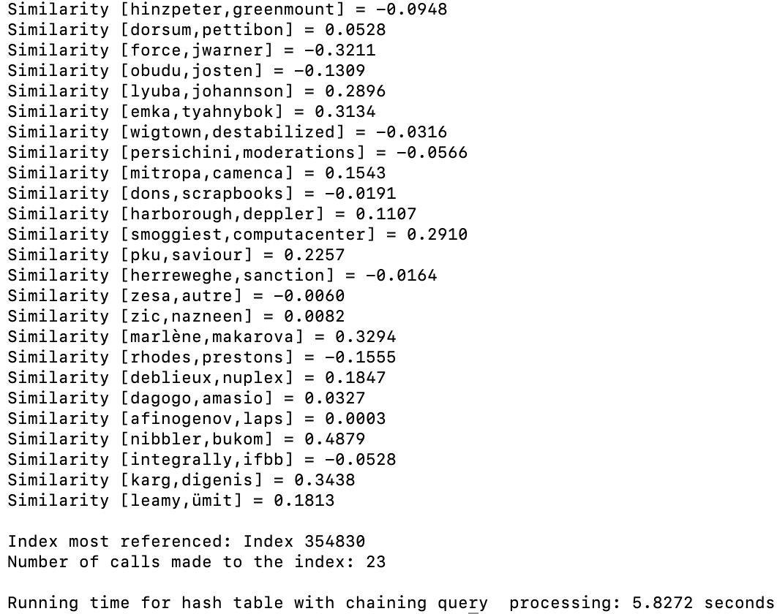

Sample Output for Hash Table with Linear Probing:

Recursive Hashing Function

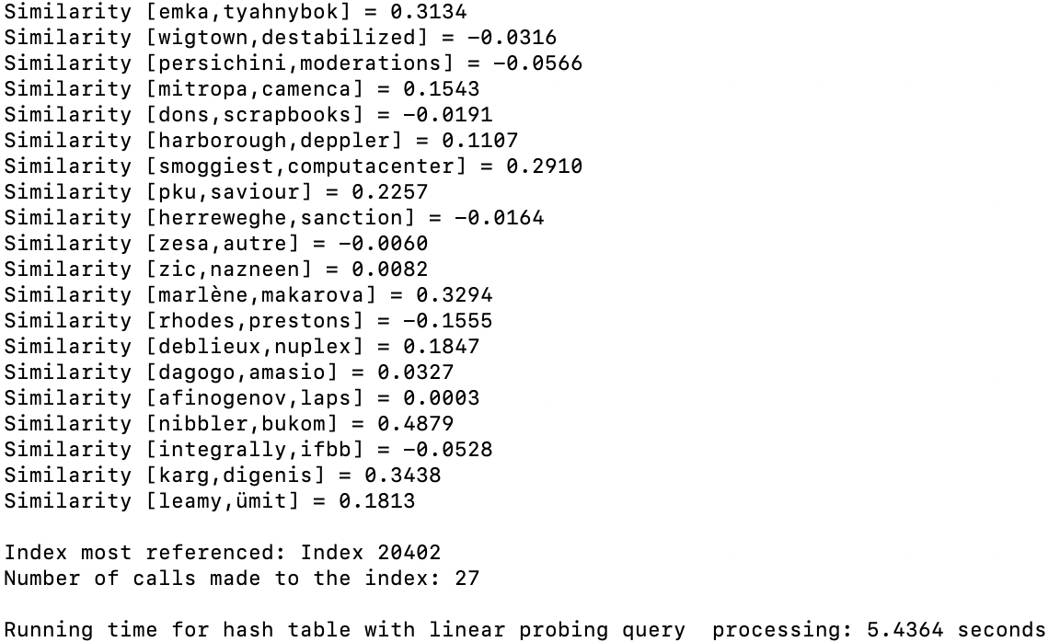

Case 1 (150,000):

Trial1_150000.txt

Trial2_150000.txt



Case 2 (200,000):

Trial1_200000.txt

Trial2_200000.txt



Case 3 (300,000):

Trial1_300000.txt

Trial2_300000.txt





The graph above summarizing Case 1 to Case 3, demonstrates the runtimes for the hash tables with chaining and linear probing. Yet again, the hash table with chaining recursive hash function had the highest performance time. By obtaining a summation of the string’s ascii values as polynomials, it is less likely for multiple words to be mapped to the same index. The graph also illustrates how consistent the custom hash function is for both the chaining and linear probing hash tables. In both instances, the values seemed to dramatically increase at 200,000 elements. When compared to the recursive chaining hash function, the custom hash function’s running times were two times larger. Although these custom functions were able to be populated based on the original glove file when the other linear probing functions failed to, the inefficiency of the custom hash functions is more evident with larger values. This may be attributed to the fact that the custom hash function was merged result of using the murmur hash function and Horner’s method. By converting the current summation to bits and then XORing the result, I probably counteracted the efficiency of both methods. However, it would be unfair to completely discourage the use of combining the methods since the values were consistent and able to function with the original glove file. Lastly, the chaining’s ascii hash functions probably resulted in lower running times due to the binary search on the data. Thus, the overall efficiency of the test runs should not be purely attributed to the hash functions themselves. Since the binary search is halving the data, finding an element is achieved in a faster period of time. If the individual buckets were not ordered, then the hash table chaining’s ascii functions would probably fail to be tested for larger files since a bucket containing hundereds of elements would have to be searched one by one.

**Load Factor – Finding Similarities:**

For the Load Factor- Finding Similairites test, three tests were run. These test focused on finding the similarities of 5,000, 50,000, and 300,000 pairs. Unlike the other tests, the load factors for each test included 0.9, 0.75, 0.5, and 0.27. As for the four ascii and string length hashing functions for linear probing, they were only included in the last test case. This is attributed to the long runtimes for 50,000 and 300,000 as documented above. Each test had two different trials with the .txt files corresponding to the trial number. Each .txt file had randomly selected pairs. I thought that this test was very important to identify how the load factor could affect the find functions. The files tested can be found in the GitHub repository under the TestTrialFiles folder.

Sample Output:

Length of string hash function

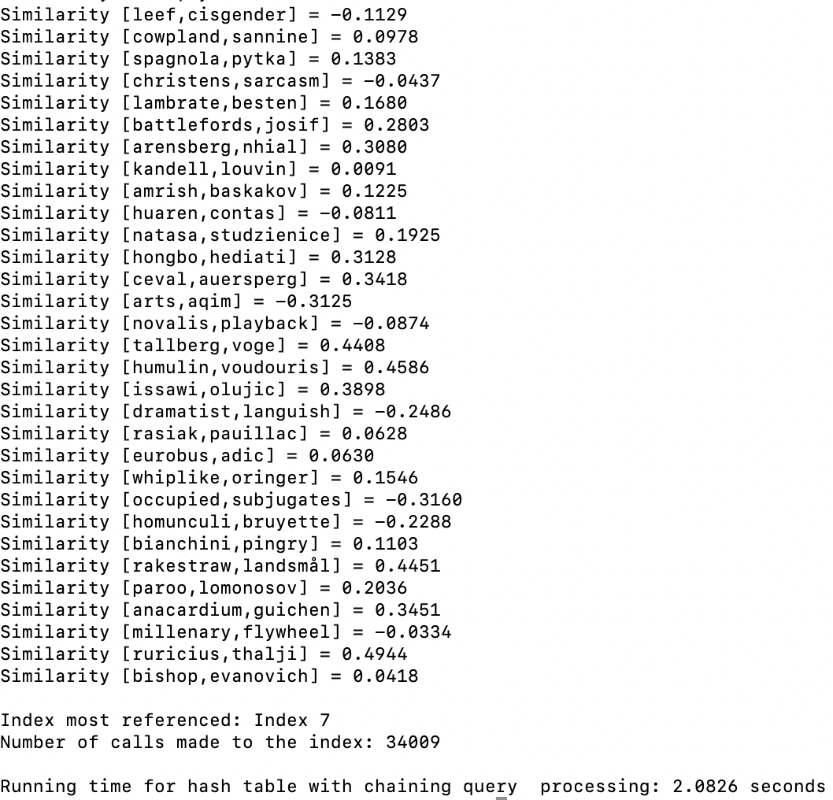

Sample Output for Hash Table with Linear Probing:

Custom hash function

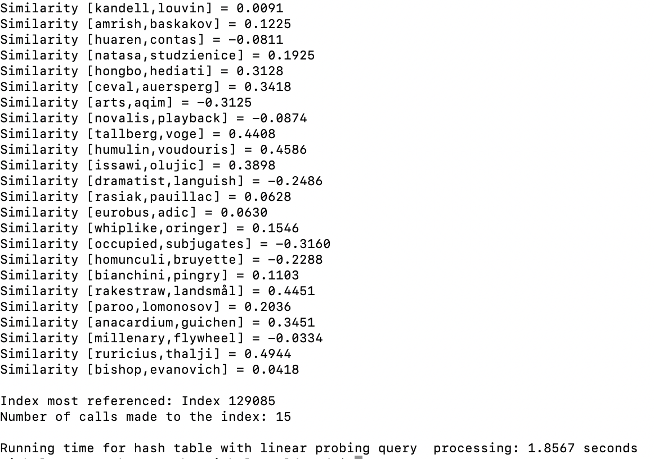

Case 1 (“300,000 Pairs”):

Trial1_300000.txt

Trial2_300000.txt









Case 2 (“50,000 Pairs”):

Trial1_50000.txt

Trial2_50000.txt









Case 3 (“5,000 Pairs”):

Trial1_5000.txt

Trial2_5000.txt









Case 4 (“Hash Table Linear Probing - 35% of Words”):

LPTrial1_500.txt

LPTrial2_500.txt









The graphs above compare the running times from the tests conducted with the running times obtained from previous tests with a load factor of 0.9, 0.75, 0.5, and 0.25. From these tests, the overall effects of the load factors were not noticeable, except for the Linear Probing custom and recursive hash functions. This is probably due to the hash functions themselves. For example, the string length hash function will probably only map to the first ten indices, regardless of whether the table size increases. This results in approximately the same amount of collisions, and therefore the same amount of running time. As for the running times for the linear probing recursive and custom functions, the runtimes are probably longer due to the data’s distribution. By having inserted so closely together, more collisions occur resulting in longer searching times. Although the load factor of 0.75 did sometimes have larger runtimes, it is also important to recall the construction times. For the string length, the load factor of 0.27 had the highest runtime. The difference between the runtimes for search was approximately 0.10 seconds whereas the difference between construction times was about 14 seconds. Thus, 0.75 is the optimal choice when compared to 0.27 because it not only has faster construction times but can also find an element at approximately the same time as the hashing tables with a load factor of 0.27. Additionally, the dramatic difference between the linear probing with a load factor of 0.9 and the chaining with a load factor of 0.9 is also attributed to the insertion methods. For the hash table with chaining, a binary insertion is performed, allowing the data is the bucket to repeatedly be halved. For the linear insertions, each bucket has to be checked one by one until the word is found.

**Maximum Index Reference:**

For the maximum index reference test, one test was ran. This tests focused identifying the maximum number of times an index was referenced during the search operations. For the four linear probing functions, the maximum number of times an index was referenced was based on a search for 2000 word pairs. For the other functions, the maximum number of times an index was referenced was based on a search for 150,000 pairs of words. I thought that this test was very important to identify the distribution of the data. I specifically chose these file sizes of 150,000 and 2,000 since they were central values for the pairs sizes. The files tested can be found in the GitHub repository under the TestTrialFiles folder.

Case 1 (“Maximum Index Reference”):

Trial1_150000.txt

LPTrial1_2000.txt









From the first bar chart, it is evident that the string length chaining hash function had the most searches tied to a specific index. This is probably because the word sizes do not vary. On average a majority of the words range from 5 to 7 letters. Thus, it is easy to identify why an index was being called more than 50,000 times. Although the index was dramatically referenced more than the other indices, the function still had lower performance times then the custom hashing functions. At first this may seem startling since the custom hashing function at a maximum had an index referenced 12 times. The reason why this is occurring is due to the binary search. By having such large amounts of data, the algorithm is effectively able to divide the list and only look for a specific value in a given range. As the second graph demonstrates, the string length for the linear probing also had the largest amount of a single referenced. In all tests, the custom hashing function had the lowest index referenced. Despite this, the custom still had some of the highest performance times. When printing the contents of the hash table with chaining, a majority of the buckets had only one to five elements. As the previous lab demonstrated, binary search on data is not as effective as binary search on larger amounts of data. This could be one of the reasons why the runtimes for the string length are lower than chaining’s custom function even though the number of times an index is referenced is dramatically more.

**Running Time Comparisons for BST, B-Trees, and Hash Tables:**

The graphs below compare the running times for BSTs, B-Trees with max_data of 5 and 499, and hash tables. The bar chart demonstrates the running times for the construction of the data types. The first graph shows the growth in runtimes for 2,000 pairs to 5,000 pairs. The second graph shows the growth in runtimes 50,000 pairs to 100,00 pairs. The third graph shows the growth in runtimes for 150,000 to 300,000. I thought that comparing the data structures based on the number of pairs was crucial for the overall analysis.









Out of all the running times, the B-Tree with a max data of 5 had the worst running time. This is because the B-Tree not only has a height that it has to traverse, but also a list of elements within a designated node. The hash table with chaining recursive function had the overall lowest runtime. As the first graph demonstrates, initially, all the data structures have very similar running times, but as the number of pairs increases, the efficiency of the recursive function clearly shines. An ideal hash table would have found and inserted elements in constant time. With Horner’s method, this “ideal” solution is almost achievable. Whereas the B-Tree or BST have to traverse the height of the tree, the hash table looks for the bucket where the element should reside in constant time. As for the BST, its runtimes were generally the second highest. Since the BST had a height of 47 nodes, at most these 47 nodes needed to compared. As for the hash functions, some, like the recursive function, only needed to evaluate two or three items before finding the correct word embedding. As for the custom hash functions, the running times were generally in the middle of all the other running times. For the small, average, and medium files, the custom hash function had lower performance times than the BST and B-Trees. However, for the large files, the custom functions were, on average, higher than all the tree running times, except for the BST. Additionally, based on the running times for the hash table with chaining ascii functions, the hashing functions still obtained lower runtimes than the trees. These functions were omitted from the final graphs since they were not able to run on the larger and smaller file sizes. However, looking at the tables of data, the ascii functions all had running times below ten seconds for 300,000 elements. All of the trees for 300,000 had running times above ten seconds. As for the construction, the hash tables had the lowest and highest performance times. Yet again, the recursive chaining had one of the lowest running times. The chaining ascii sum hash function had the highest, reaching nearly 20 seconds. By having a hashing function that mapped multiple values to the same index, the longer runtime is clearly evident. Overall, the hash tables had the fastest implementations for finding similarities and construction times. The hash table with chaining’s recursive method had the fastest running times, proving the superiority of hash tables with the proper hash function. As for the load factor, when considering the construction time and search time, the most ideal load factor would be 0.75. In many of the cases, the hash table with a load factor was able to find the same results in approximately the same amount of time as a hash table with a lower load factor. However, the hash table with a load factor not only had faster construction times but also required less space. Additionally, across all the functions, the hash table with a load factor of 0.75 was the most consistent.

**Conclusion**

In all, I learned how to how to transform a program using one data structure to another data structure. I have never had a lab that focuses on implementing the same problem with different data structures, so I thought that this lab was very interesting. By chaining the data structures, I was able to use a lot of pre-existing code from Lab 4. Due to this I learned the importance of having separate methods that perform their own unique task. For example, if I had just decided to group all the methods together in Lab 4, then I probably would have to redo the entire program for Lab 5. By dividing the methods, I was easily able to copy and paste existing lines of code and update any sections as necessary. From this lab I also learned how crucial a good hashing function is for hash tables. If one were to choose a hash function that maps multiple values to the same index, then the running times would be significantly higher. This can clearly be seen from the hash table with linear probing’s ascii function. With a good hash function, like the recursive Horner’s method function, one could create a data structure that could insert and find elements quickly. Although the recursive hash function resulted in faster performance times, I believe that the trees have the most consistent data. For example, when viewing the tables of information from Lab 4, there are not as much spikes in the data. Thus, I learned that while hash tables can be more efficient than trees, collisions can result in unforeseen problems. In all, this lab allowed me to compare trees and hash tables. Prior to the lab, I had only compared the different implementations of the same data structure. By completing this lab, I now realize that there are many different data structures to use for the same implementation. In order to pick the best data structure, one must be more informed. For example, if an individual wanted a consistent way to store and receive data without having to worry about collisions, I would recommend a B-Tree. However, if someone wanted an incredibly fast way to store and retrieve data, I would recommend a hash table with the recursive hashing function. I would also note that one must be careful in the event of collisions.

**Appendix A**

**NicholeMaldonado_Lab4.py**

**WordEmbedding.py**

**BSTClass.py**

**BTreeClass.py**

**FileCreation.py**

I certify that this project is entirely my own work. I wrote, debugged, and tested the code being presented, performed the experiments, and wrote the report. I also certify that I did not share my code or report or provided inappropriate assistance to any student in the class.

X



-----------------------------------